**Identification of Medicinal Plants using Deep Learning Techniques**

**ABSTRACT:** The therapeutic nature of medicinal plants and their ability to heal many diseases raises the need for their automatic identifcation. Diferent parts of plants that help in their identifcation include root, fruit, bark, stem but leaf images have been widely used as they are an abundant source of information and are also easily available. This work explores the branch of Artifcial Intelligence, called deep learning, and proposes an Ensemble learning approach to rapidly detect medicinal plants using the leaf image. The medicinal leaf dataset consists of 30 classes. Transfer learning approach was used to initialize the parameters and pretrain Neural networks namely MobileNetV2, InceptionV3, and ResNet50. These component models were used to extract features from the input images and the softmax layer connected to the Dense Layer was used as the classifer to train the models on the concerned dataset. The obtained accuracies were validated using threefold and fvefold crossvalidation. The Ensemble Deep Learning- Automatic Medicinal Leaf Identifcation (EDL-AMLI) classifer based on the weighted average of the component model outputs was used as the fnal classifer. It was observed that the EDL-AMLI outperformed the state-of-the-art pre-trained models such as MobileNetV2, InceptionV3, and ResNet50 by achieving good accuracy on the test set and average accuracy using threefold and fvefold cross validation

**Keyword:** Medicinal, Ulcers, deep learning, Mobile net model, minutiae

**Existing Method:**

In the existing there are methods implemented to classify medical plant classification in deep learning. In method we are performing the classification medical plant identification using Resnet, vgg16 of deep learning along with the Machine learning methods. As image analysis based approaches for classification of medical plant

.

**Disadvantages:**

• Less feature compatibility

• Low accuracy

**Proposed System:**

In purposed method we are performing the classification of either the image is medical plant identification using Mobile net of deep learning along with the Machine learning methods. As image analysis based approaches for medical plant classification and authentication. Hence, proper classification is important for the medical plant that which will be possible by using our proposed method. Block diagram of proposed method is shown below.

.

**Block Diagram:**

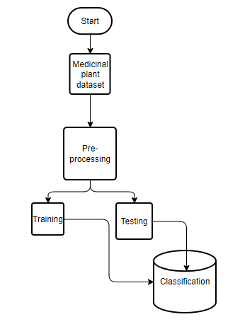

**Fig 1. Block diagram of proposed method**

**Advantages**:

* Accurate classification
* Less complexity
* High performance
* Easy Identification

**MODULES:**

**System**

**User**

**1. System:**

1.1 Create Dataset:

The dataset containing images of the Medicinal plant Classification i.e., normal are to be classified is split into training and testing dataset with the test size of 30-20%.

1.2 Pre-processing:

Resizing and reshaping the images into appropriate format to train our model.

1.3 Training:

Use the pre-processed training dataset is used to train our model using Mobile net Deep learning algorithm along with some of the transfer learning methods.

1.4 Classification:

The results of our model are display of Medicinal plant images classification.

**2. User:**

2.1 Upload Image

The user has to upload an image which needs to be classified.

2.2 View Results

The classified image results are viewed by user.

**SYSTEM SPECIFICATIONS:**

# **H/W Specifications:**

# Processor : I5/Intel Processor

# RAM : 8GB (min)

* Hard Disk : 128 GB

**S/W Specifications:**

* Operating System : Windows 10
* Server-side Script : Python 3.6
* IDE : PyCharm,Jupyter notebook
* Libraries Used : Numpy, IO, OS, Flask, keras, pandas, tensorflow,OpenCV, pytesseract OCR

**LEARNING OUTCOMES:**

* Practical exposure to
  + - * Hardware and software tools
      * Solution providing for real time problems
      * Working with team/individual
      * Work on creative ideas
* Testing techniques
* Error correction mechanisms
* What type of technology versions is used?
* Working of Tensor Flow
* Implementation of Deep Learning techniques
* Working of CNN algorithm
* Working of Transfer Learning methods
* Building of model creations
* Scope of project
* Applications of the project
* About Python language
* About Deep Learning Frameworks
* Use of Data Science